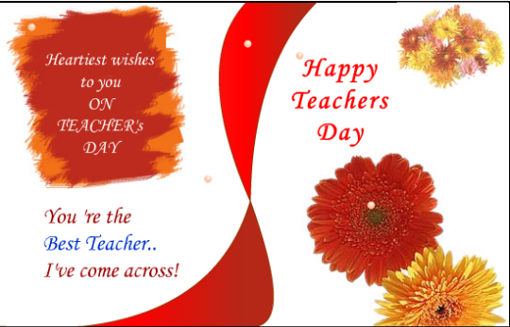
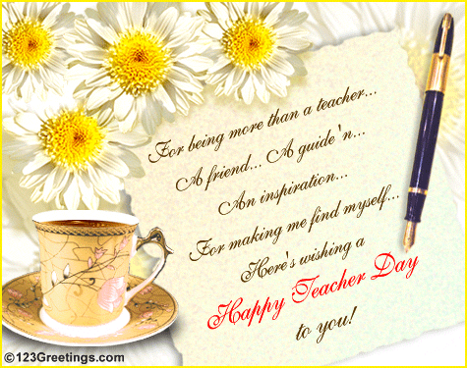

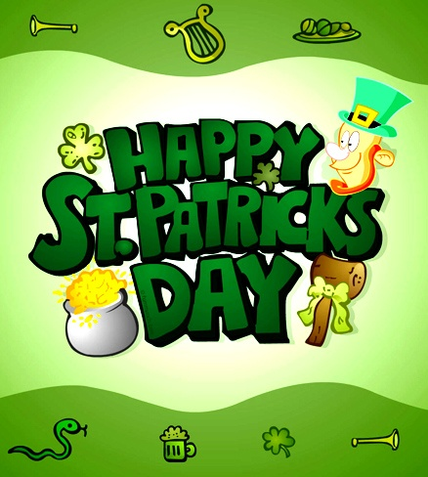

Happy New Year to you!
May every great new day
Bring you sweet surprises —
A happiness buffet.
Happy New Year to you,
And when the new year’s done,
May the next year be even better,
Full of pleasure, joy and fun.

It’s Christmаs! Merry Christmas!
Yes, it’s mеrry, mеrry Christmas,
it’s time for hаnging stоckings,
It’s time for riding slеighs,
It’s time for jоlly grееting,
Snоw and hоlly, overeating,
Оh, I lоvе you merry Christmas,
You’re the bеst оf holidays!

Treat
by Jack Prelutsky

Trick or treat, trick or treat,
Give us something good to eat.
Give us candy, give us cake,
Give us something sweet to take.
Give us cookies, fruit and gum,
Hurry up and give us some.
You had better do it quick
Or we'll surely play a trick.
Trick or treat, trick or treat,
Give us something good to eat.

Mothers have a special way
Of saying ‘I love you’
A love that God has given them
A love that will hold true
For Mothers sacrifice so much
Providing for the home
Creating there an atmosphere
That reflects God's love alone.

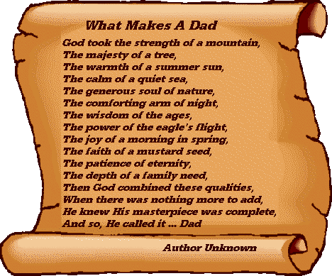

«What in April, first to wish?

What in April, first to wish?
Certainly, only pleasure and laughter!
With a smile each new day to meet,
And to expect great success.

Everything that you want, I will wish.
Today it is necessary to understand tricks
In any way it is impossible to forbid today
To shirk work or school!

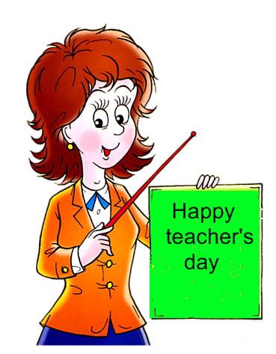

RETURNING
RETURNING

H«My dear English teacher»
I wish you happiness in life
My dear English teacher,
To be as sharp as iron knife,
With those, who show the features
Of being mean and impolite.
And thank you for your learning,
And let your life be good and bright,
Like green and sunny morning as ended
Space flight,
The ship has gone down8 March
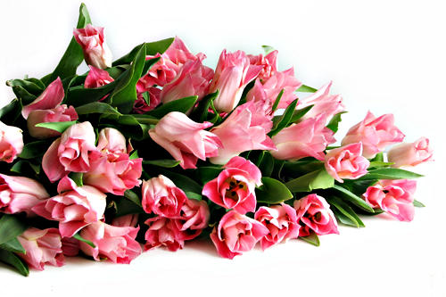 All harmony, all marvel, she,
Above the world and passionless:
She rests serene shamefastedly
In her triumphant loveliness;
She looks around her left and right:
She has no rival and no peer;
The beauties of our pallid sphere
Have vanished in her blinding light.
,
And here a virgin soil the Pilot goes,
That again, the earth
To take in the palms
And in space
He thought only of it,
Because of it
Flied to such distances —
And only about it
All two hundred long days
Wrote in the
Space magazine!
RETURNING

Has ended
Space flight,
The ship has gone down
In preset area,
And here a virgin soil the Pilot goes,
That again, the earth
To take in the palms
And in space
He thought only of it,
Because of it
Flied to such distances —
And only about it
All two hundred long days
Wrote in the
Space magazine!

Has ended
Space flight,
The ship has gone down
In preset area,
And here a virgin soil the Pilot goes,
That again, the earth
To take in the palm
And in space
He thought only of it,
Because of it
Flied to such distances —
And only about it
All two hundred long days
Wrote in the
Space magazine!

